Time-Frequency Analysis
VStar provides time-frequency analysis functionality in the form of Weighted Wavelet Z-Transform (WWZ) (Foster 1996). The user specifies a series (e.g. Visual, Johnson V), a frequency or period range, and a resolution; the result is a visualization of how the period changes over time. This can be viewed as a 2D graph, a contour plot, a rotatable 3D graph, or in tabular form. Periods at particular points in time can be selected for phase plot creation. A detailed explanation of the statistical analysis techniques being utilized here is beyond the scope of this document. The interested reader is referred to Foster (2010) and References and Further Reading.

The following shows the period change for T UMi in the year range 1913 to 2009. Here the color represents the WWZ statistic, the strength of a periodicity, at a particular time. This example is discussed in Foster (2010).

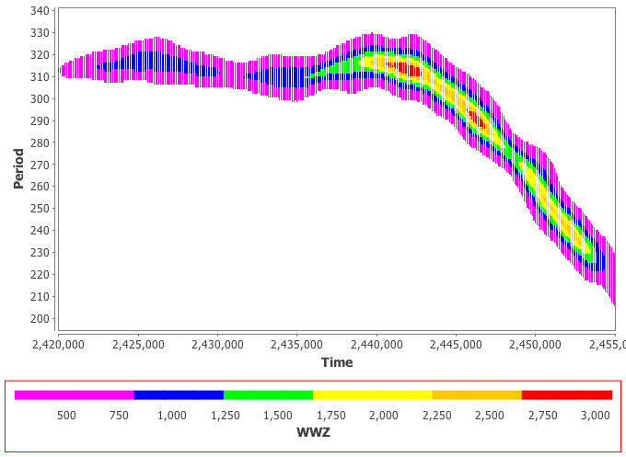

This section explores WWZ via T UMi.

The T UMi dataset below, taken from the AAVSO International Database (AID), spans the JD range 2,420,000 to 2,455,000. Even a visual inspection suggests amplitude and possible period change.

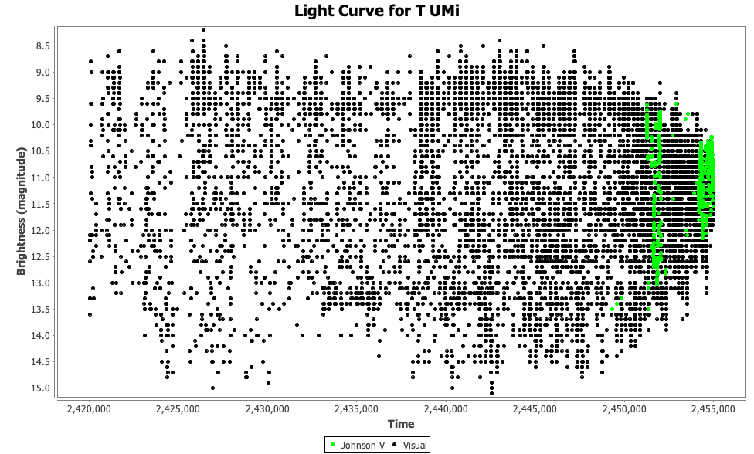

Creating a phase plot with periods taken from DCDFT (Date Compensated Discrete Fourier Transform) in VStar does not result in an obviously "clean" fit over the time range, as evidenced by DCDFT high-power top-hits (via Analysis → DCDFT Standard Scan...):
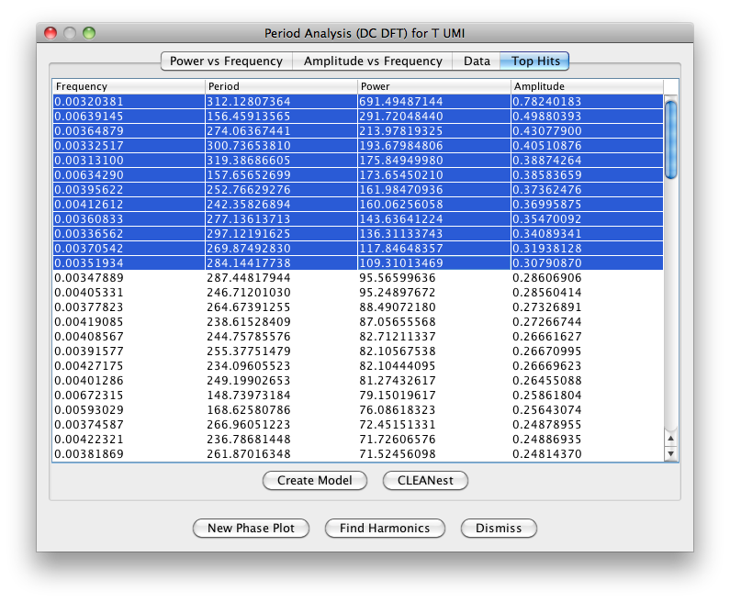
WWZ helps to explain why. It is available via two Analysis menu items and a toolbar button.

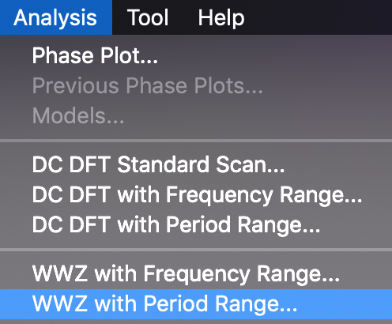

The toolbar button corresponds to the WWZ with Period Range item of the Analysis menu.

Applying WWZ to the dataset requires selecting the series to be analyzed, then the following parameters:

- Minimum frequency or period.
- Maximum frequency or period.
- Frequency or period step: this is the resolution in the frequency domain.
- Decay: this is the wavelet window; smaller values yield better resolution of variation.
- Time divisions, yielding time steps revealed by the “vertical banding” in the contour plot seen in the first figure of this section. The means by which the time steps used per frequency under test are computed is as follows:

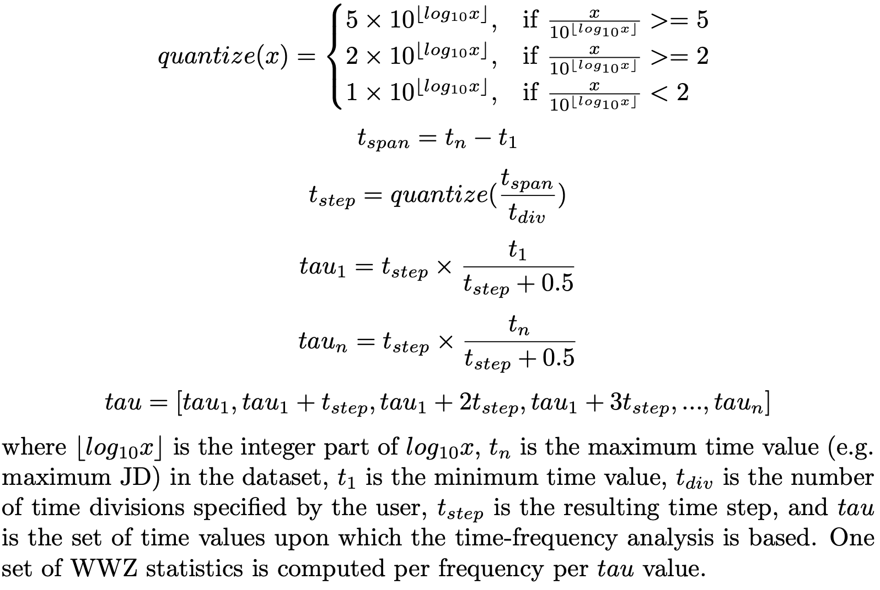
For T UMi, selecting Analysis → WWZ with Period Range, selecting the Visual series and entering values of 100 days (min period), 500 days (max period), 1 day (period resolution), 0.001 (decay) and 200 (time divisions) for the above parameters, gives a plot of period vs time:
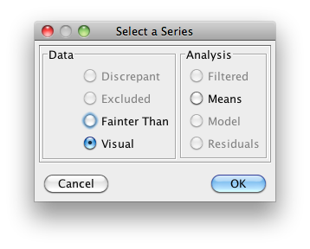 | 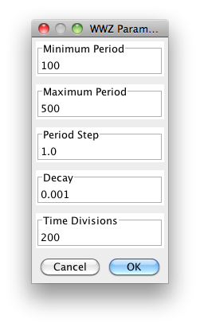

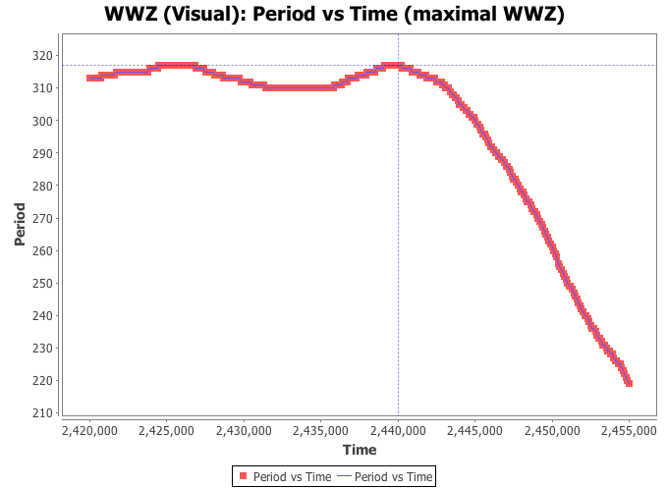

The contour plot at the start of this section adds the WWZ statistic to the Period vs Time plot above. The Result dialog provides a number of other plots and tables. One of these is a 3D plot that provides the same information as the contour plot but allows rotation in all axes.
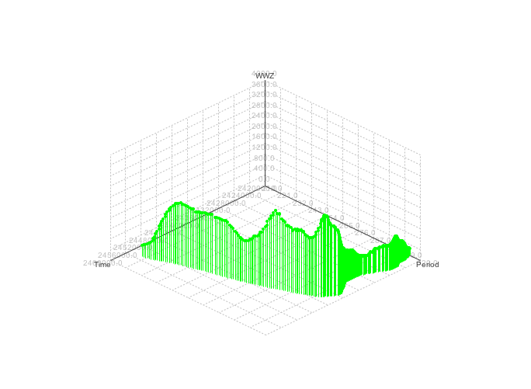
The WWZ algorithm generates the following statistics for the specified series and frequency or period range and time resolution which VStar presents in plot or tabular form (adapted from the AAVSO Fortran WWZ implementation documentation):

- Time: The time being examined, in JD.
- Frequency: The frequency being tested, in cycles per time unit.
- Period: The corresponding period under test, in JD.
- WWZ: Value of the WWZ; this is approximately an F-statistic with Effective number of data and 2 degrees of freedom, and expected value 1. In short, it indicates whether or not there is a periodic fluctuation of the given frequency at the given time.
- Semi-amplitude: Weighted wavelet amplitude; if the signal is periodic at the frequency being tested, this gives the (real semi-) amplitude of the corresponding best-fit sinusoid.
- Mean magnitude: Mean apparent magnitude of the object at the corresponding time.
- Effective number of data: The effective number of data for the given time and frequency being tested.

The maximal WWZ table shows the points at which the WWZ statistic was maximal:

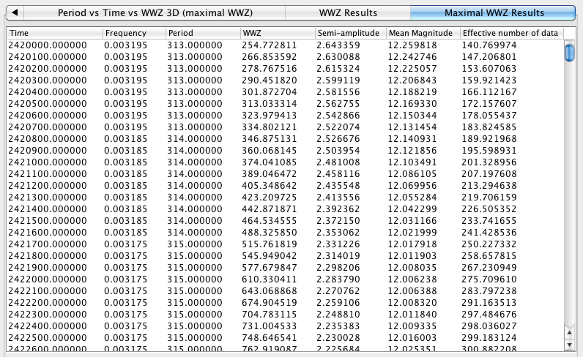

A phase plot can be created from a selected result table row or plot datapoint in the WWZ results dialog via the New Phase Plot button.
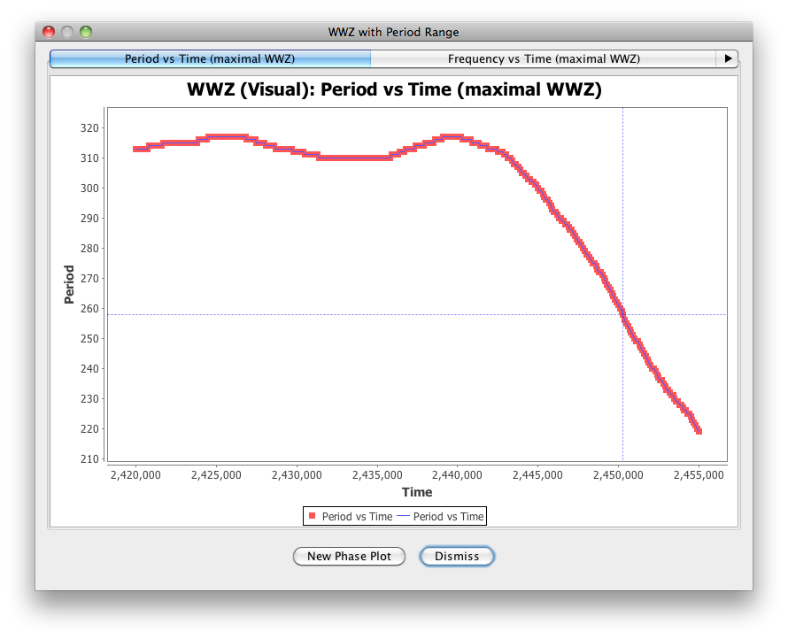
The AAVSO Fortran WWZ implementation’s documentation has a section on suggested parameter values, minimally adapted below:

The chosen frequency range should only cover the range of frequencies of astrophysical interest to reduce computation time. For Mira and Semiregular variables, choosing a frequency range between 0.0001 (P = 10000 days) and 0.02 (P = 50 days) with delta f of 0.00001 is reasonable, and should not oversample the frequency spectrum too severely. Be sure to choose frequency values that are physically relevant to the system you are studying, and to the data available.

The decay constant, c, defines the width of the wavelet "window". It defines the number of cycles of a given frequency f expected within the window. Smaller values of c will produce wider windows. Reasonable values of c are between 0.001 and 0.0125. Note that using small values of c will result in improved frequency resolution of variations, but will smear out temporal variations. Conversely, large values of c will improve the temporal resolution, but will generate larger uncertainties in peak frequency.

WWZ scans the data set starting from the earliest data and progressing to the latest. If you notice that the program returns zero values of the WWZ statistic, then you probably have a large data gap just prior to the point where the zero values begin. Consider truncating the data set to include only data before or after the gap, or split the data and analyze both sets separately.

For another example of using WWZ in VStar, see the following which includes the R Dor example from Foster (2010) mentioned at the start of this section.

http://dbenn.wordpress.com/2011/08/30/weighted-wavelet-z-transform-wwz-in-vstar

